**National University of Computer & Emerging Sciences Karachi Campus**



# “SINDH BUS SERVICE SYSTEM”

**Project Proposal**

**Object-Oriented Programming Section: J**

**Group Members:**

**23K-2001 Muzammil Siddiqui**

**23K-3033 Uzair Haroon**

**23K-0800 Mufeez Hanif**

* **Introduction:**

We aim to develop a management system for Bus Service of Karachi that comprises of our core concepts of Object-Oriented Programming. Our target is to efficiently maintain a system of buses, their routes, stations, availability, and other functionalities.

* **Existing System:**

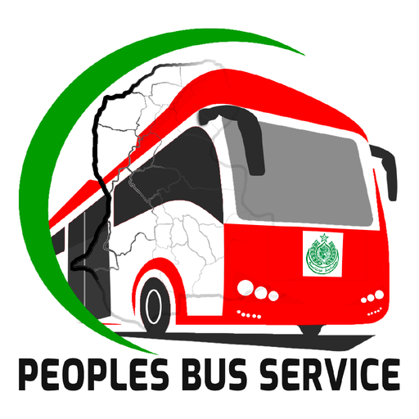***People’s Bus Service*** app is available on the Appstore which allows locals to plan their trips, offering schedule and bus arrival times. The current application shows the closest bus stop, notifying changes to services and locations. It was launched in March 2023 but last updated only during June 2023.



Similarly, ***Green Line - Karachi Metrobus*** App is also available but it is nowhere near functional regarding a bus service application. Availability, schedule, booking, and station info need to be added to the app.

* **Problem Statement:**
* Available seats and capacity are not displayed on the app.
* Live tracking feature is missing.
* Fare payment is not synchronized with online mobile payments or e-transactions.
* Only Red buses are included whereas there is no option for Pink Bus or Electric Bus, or more buses that would come into service in the future.
* Routes are not synchronized with Google Maps for traffic assistance and prevention of blockade of routes.
* All routes have been displayed together on the routes page, which affects user experience.
* Bus availability is not displayed in case of unforeseen circumstances.
* **Proposed Solution:**
* We will add info regarding available seats and bus capacity.
* Estimated time arrival of bus depending on conditions such as usual traffic.
* E-transaction feature for fare payment by redirecting to the respective platform.
* Add bus feature through administrative access utilized by a passkey that will be only granted to admins.
* City-wise and further town-wise alignment of routes to ease user-experience.
* Displaying bus availability at the time of displaying fastest routes to accommodate users in case of unexpected issues such as holidays or blockade.
* **Salient Features:**
* Bus routes.
* Bus availability.
* Bus capacity.
* Station Info.
* Records log.
* Add new bus to routes.
* Add new routes.
* Friendly & captivating GUI.
* Route relationship.
* Fastest route selection.
* **Tools & Technologies:**
* C++ Programming Language
* Visual Studio Code
* Windows



Suggestions:

____________________________________________________________________________________________________________________________________________________